**Homework 4**

Upload the answers of the following questions from *Google Classroom* until **December 10, 2017, 23:55.**

Upload only a single *.cs file.

The name of the file: **number_name_surname.cs**

For example: 2017510028_ali_yildirim.cs

**Question**

Write a program that takes an ***equation***as string and the values of the variables ***x*** and ***y*** from the user and prints whether the equation is true or not.

In other words, the program should determine whether the left hand side of the equation is equal to the right hand side of the equation, or not.

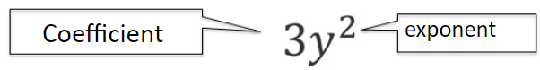

The user will enter a correct equation. Don't check its correctness.

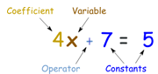The left hand side of the equation includes only *x* variable,

while the right hand side of the equation includes only *y* variable.

All coefficients and exponents will be only digits (between 1 and 9).

The equation will not include constants.

The equation includes only addition operator (+).

The output must be only *true* or *false*.

**Sample screenshot1:**

|  |  |
| --- | --- |
| Inputs:  4x3+5x2+7x=y4  x=1  y=2  Output: true | (4x3+5x2+7x=y4)  (because 4+5+7=16 and 24=16) |

**Sample screenshot2:**

|  |  |
| --- | --- |
| Inputs:  4x+x6+x+4x3=y9+y8+y2+2y3+y6  x=3  y=2  Output: true | (4x+x6+x+4x3=y9+y8+y2+2y3+y6)  (because  12+729+3+108=852 and  512+256+4+16+64=852) |

**Sample screenshot3:**

|  |
| --- |
| Inputs:  5x4+2x3=2y+3y2  x=5  y=4  Output: false |

**Notes:**

1. You should use meaningful variable names, appropriate comments, and good prompting messages.

2. If you are late, your grade will be decreased 10 points for each day. After five days, your assignment will not be

accepted.

3. Assignment must be your individual work. Cheating is strictly prohibited. If any cheating occurs, your assignment will be graded with zero (0). It is real.